

UNIVERSITY KUALA LUMPUR
MALAYSIAN INSTITUTE OF INFORMATION TECHNOLOGY (MIIT)

ISB 42303
SOFTWARE CONFIGURATION MANAGEMENT
MINI PROJECT PROPOSAL (CLINIC MANAGEMENT SYSTEM)
PREPARED BY:
CoqBadak
NO. | NAME | STUDENT ID NO.
1. | MUHAMMAD HAFIZZUDIN BIN MOHD ZAKI | 52213117401
2. | MOHD SYAKIR BIN MUHAMAD SHUKRI | 52213117383
3. | NUR ALIAH BINTI ANUAR | 52213117380
4. | MUHAMMAD FARRIS IKHZUAN BIN RUSLI | 52213117384

PREPARED FOR:
Ms. nurul sharaz binti azmanuddin

Table of Contents

1.0 ABSTRACT 1
2.0 PROJECT BACKGROUND 2
3.0 INTRODUCTION 3
4.0 PROBLEM STATEMENT 4
4.1 LIST OF PROBLEMS 5
4.2 PROPOSED SOLUTION 6
5.0 OBJECTIVES OF REUSE 8
6.0 SCOPE OF THE PROJECT 9
6.1 USER OF THE SYSTEM 10
7.0 PROTOTYPE DEVELOPMENT 11
8.0 ORGANIZATIONAL CHART 13
9.0 AVAILABILITY OF RESOURCE 13
9.1 TOOL USED 13
9.0 AVAILABILITY OF RESOURCE 14
9.1 HARDWARE/SOFTWARE REQUIREMENTS 14
9.2 BUDGET REQUIREMENTS 15
9.3 TOOLS USED 15
10.0 EXPLANATION ON EXISTING INTERFACE 17
10.1 BENCHMARK SYSTEM 17
10.2 STRENGTHS 17
10.3 WEAKNESS 17
10.4 INTERFACES OF SOFTCLINIC 18
10.5 SOLUTION FOR THE WEAKNESS 20
11.0 FUTURE RECOMMENDATION 21
12.0 CONCLUSION 22
13.0 BIBLIOGRAPHY 23

ABSTRACT

This project is a clinic management system that will be used to solve the current problems facing by the local clinic in Malaysia. Clinic Management System is a web-based platform system. The main objectives of this project are to improve the business process of the clinic in Malaysia by using information technology and also enhance the current clinic management software in the market. The scope of this project includes systematic appointment, monitoring system and to reduce the workloads by the staff by providing an automotive procedure. As this is a web-based platform system, PHP is the programming language and the project is developed under DEV PHP. The clinic management system can divide into a few phases and each phase consists of a few modules which can easily develop and build up the system in a short time.

2.0 PROJECT BACKGROUND

Health care is the diagnosis, treatment, and prevention of disease, illness, injury, and other physical and mental impairments in human beings. Health care is delivered by practitioners in dentistry, medicine, optometry, pharmacy, psychology, and other care providers. [5] When IT starts to be mature, it helps to reduce the workloads and process time for the business process in the health care industry. The business process includes patient registration, appointment, billing, inventory and so on. Nowadays, some of the IT technologies are used to research those new diseases. With the help of the IT, health care industry is having a very bright future in developing of health care system that can help patients over the world.
The title of the Clinic Management System in this project is clear enough because the title is simple for users' understanding. The clinic management system would help to solve the problems by replacing the traditional way of paper works to the information system. However, the title is not specific enough because it is too general as people have different views regarding the system. For instance, some users might think that this is the system that lets the doctor and nurse use a smartphone or tablet to work in the clinic. Instead, this system uses a computer to do those administration tasks with innovations.

3.0 INTRODUCTION

Nowadays, there are a lot of clinics in Malaysia. People who suffer from sick or pain will visit the clinic which nearby their location. However, most of the staff in the clinic still using paper works in their workflows. Those paper works such as patient registration using a form, patient record using a manila card, open bill statement using handwriting, record appointment using a book and so on. Because of these manual operations are done by a few nurses in a clinic, it may slow down the procedure in many ways. For example, when the doctor uses manila cards to write the patient’s diagnosis record, the manila card needs to be kept in the clinic by put them on the cupboard. Once the clinic operates for a few years, there will be a lot of manila cards on the cupboard. So, when a patient comes to the clinic, the nurse maybe needs to use 3 to 5 minutes to find the patient’s record card which is quite a wasting time.
Information technology improves a lot today. A lot of computer-based systems can help to manage the business process. Michael Hammer and James Champy define a business process as a collection of activities that take one or more kinds of input and create an output that is valuable to the customer [4]. Once a system can manage the business process, a lot of works can automation and no need manual operation. The clinic management system is one of the software available in the market and able to help the business process of a clinic.
In Malaysia, there are many clinics no matter in the public sector or private sector. However, not all of them are using the clinic management system especially the private sector. The main reason is that the system is not popular in Malaysia. A lot of private-sector clinics will choose the traditional manual operation. They feel it is not a need for a clinic to purchase a system as it is not that reliable for them. For example, everything that can be done in the system just replaces the paperwork. As doctors and nurses are not technical people, therefore they need to learn and know how the system works. They prefer to stay in the old way which is paperwork and it is quite convenient for them. Data inconsistency is also another reason they think about it. Most of the staff worry about the power failure and hardware failure of the computer which may cause data loss. From the above-stated points, we can know that there are a lot of problems that exist in the traditional manual operations and available systems in the market.

4.0 PROBLEM STATEMENT

Clinic Management System is being expanded by the conventional paper-based control system used in the clinic. Based on the conventional system, the patient comes to the clinic for the first time is reported through the system. The assistant assists the patient by documenting his personal information in a form. The patient receives the medication, and information is documented in a file about the procedure. The system manages clinic activities but the previous system has caused user problems.
Patients get frustrated waiting longer in the clinic because there is no system to keep track of their waiting time. Through the traditional method also, it will be hard and time consuming for the clinic assistant to search medical records [1]
For the current system, most public clinics were still implemented the manual procedure, it also easy to lost a record with this method and waste money to purchase paper frequently. [2]
Particularly for data retrieval, there are some problems arise. The clinic is having a patient data problem. The doctor needs to refer the nurses for the patient past and current records. Sometimes there are also duplicate patient details if the patient is not sure whether they have arrived at the clinic beforehand. So, the admin considers the patient as a new patient and add new data. [3]

4.1 LIST OF PROBLEMS

Module | Problem
Appointment module | In the clinic, patients get irritated waiting longer because there is no method to keep track of their waiting time
Registration module | For the current system, the manual procedure still applied to most public clinics
Monitor module | The doctor will refer the nurses for past and present records of the patient
  - Compare with the available system, there are a lot of modules inside. We will focus on the problems in these three modules which are appointment, registration, and monitor.

  - Table 1.0 Problem Statement in Appointment, Registration and Monitor Module

4.2 PROPOSED SOLUTION

This clinic management system will provide a clinic with high-efficiency management tools, computerize and systematic patients record, inventory records, and appointment detail. It basically will do all the daily tasks of clinic activities [1]. The following are the proposed solution for the existing clinic management system:

- The system would easily track essentials details for the clinic[2].
- To access the system every user, need to sign in. The authority for access rights of the user is separated into three types.
- Through the system it can track and summaries patient historical medical record
- The system is systematic and organized than a hand written record
- This system can reduce the amount of time spent searching a record because all in one screen[2].
- All the data in the system will be store in database to ensure security
- This new system is 100% accurate and saves time
- Efficiency: The system allows the user to open several tasks at one time while using the system.
- Work load: This system can easy update information thus reduces the user workload
- Easy statements: Day-end statement easily taken out without getting headaches on browsing through the day end statements

5.0 OBJECTIVES OF REUSE

The reuse of software components is the gateway to significant productivity gains. Reuse is basically including the use of previously learned concepts or objects in a new situation, encoding information on creation at various levels of abstraction, storing this representation for future reference, balancing new and old situations, duplicating objects and behavior already developed and adapting them to new requirements[7].
Software reuse can cut software development time and costs. The objective of software reuse is as follows:
- Increase software productivity, shorten software development time[8]
- Improve software system interoperability
- Develop software with fewer people
- Move personnel more easily from project to project
- Reduce software development and maintenance [8]
- Produce more standardized software
- Produce better quality software[8]

The accumulated defect fixes result in a higher quality work product as work products are used several times. Reuse often avoids and removes defects earlier in the life cycle because the cost of detection and debugging defects can be amortized over a larger number of uses.

6.0 SCOPE OF THE PROJECT

This project aims to develop a clinic management system for the clinic located in Malaysia which is still using manual operation – paperwork. This system can be used by a doctor and nurse. It suits any age of patients especially the old folks. The clinic management system includes a combination of modules and most of the basic modules already done in the available system in the market. To attract more clinics to use the system, from the problem statement that I mentioned above, I would like to focus on 3 modules here which are:

- Appointment module
The patient can make an appointment through the system rather than call on the clinic to make an appointment
- Registration module
When a patient comes to the clinic, he/she needs to register first if it is the first-time visitation. The registration processes will be automated rather than manual by an insert into the form provided by the system for their basic information based on this system patient shall to register the system with their username and password before to login into the system.
- Monitor
When a patient wants to see a doctor, first he/she needs to inform the counter and the nurse. The monitoring process for this clinic management system which is the admin and doctor can monitor the patient from the dashboard.

6.1 USER OF THE SYSTEM

- Patients Module
A patient needs to register before using the facilities at the clinic. All the information will be kept in the database. Through this module, the nurse can add the patients’ info and their conservator info. This module is for the patient only to create made appointment and chose who’s the doctor respectively. Through this module, the patient can see the appointment schedule in a tabular view.

- Doctor Module
This module is for the doctor only to view the patient who made an appointment and became under his responsibility. Through this module, the doctor can see the patient's history and add medicine to him. It also manages an appointment made by a nurse/doctor to the patient. Though it’s the particular doctor can be assigned with the registered patient. Moreover, a doctor can view all patients' that have been added to the system and their data. Through this module doctor/nurse can add new patients and also can search for any patient easily to add appointment, view or Edit or delete his data.

- Admin Module
This module is for system users and permits them to access the system. Through this module, all users’ data will be kept and also can add a new user (Admin - Doctor-Patient).

7.0 PROTOTYPE DEVELOPMENT

During the development of the system, System Development Life Cycle (SDLC) procedures will be followed. In the System Development Life Cycle (SDLC), Structured Systems Analysis and Design Methodology (SSADM) will be applied. SSADM phased includes Planning, Analysis, Design and Implementation and Testing.

- Planning

During this phase, the objectives and goals of the system were defined clearly include the project scoped. In this case, the objectives and goals of the system are to improve the management process in clinic and at the same way to improve process of recording data and data retrieval. After this, the risks of the system are been identified and evaluated. Identify the tools that going to use in the development process.

- Analysis

This phase includes identifying the data, the functions of the system, and the requirements for the system. The content analysis will identify the content that will be provided for the user. For the clinic management system, the system would simply record basic details for all clinic personnel. When the personnel are enrolled, they will sign in to the system. The authority for access rights of the user is separated into two types which is staff and doctor. All level users can perform add, edit and delete staff records. Interaction between the user and the system is very important. Therefore, there will be an interface for the staff to search the patient record easily and efficiently from a large amount of data.

- Design

In this phase, development of the system is based on the information during planning and analysis phases. The design will include data storage, interface design, architecture design and program design the development. The Entity relation diagram will be used to show the relationship between the entities in the overall system. Meanwhile data flow diagram is design here to show the process that will take place in the system.

- Implementation

At this phase, all the design is transfer into the programming language. Prototyping approach will be used in the implementation phased. It means that the system will be keep on building and testing until the system meet the requirement during the design phased.

- Testing

After the implementation is complete, testing will be done to find any error and bugs. Black box testing and white box testing will be applied. Later, the user will do testing.

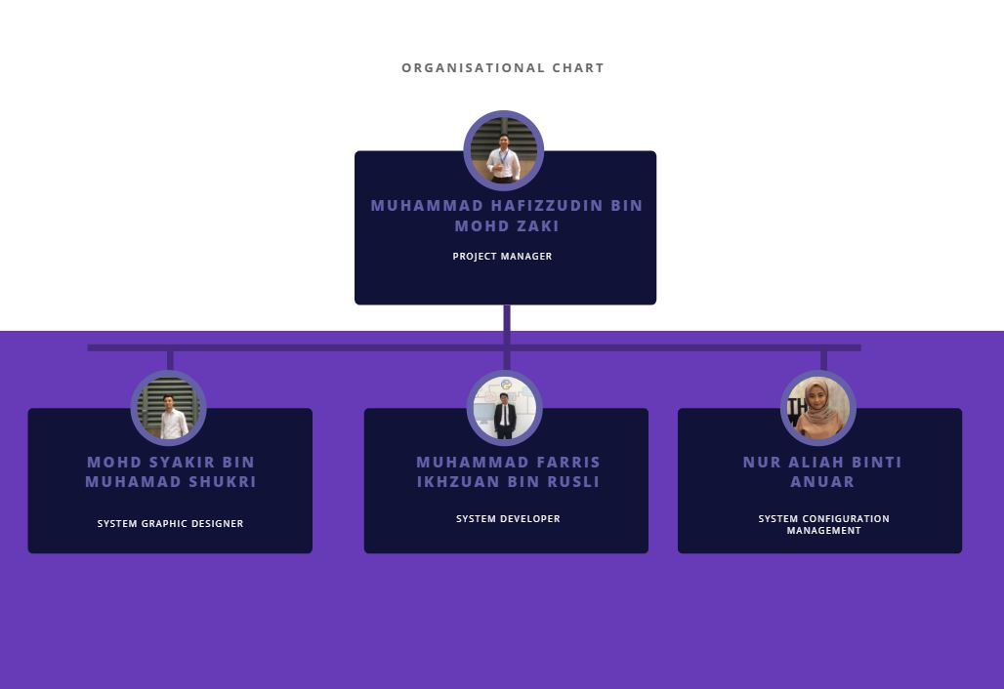
8.0 ORGANIZATIONAL CHART

  - Figure 1.0 Clinic Management System Organizational Chart

9.0 AVAILABILITY OF RESOURCE

9.1 TOOL USED

Asasass

Asasasasas

9.0 AVAILABILITY OF RESOURCE

9.1 HARDWARE/SOFTWARE REQUIREMENTS

- Hardware Requirements

Hardware Requirement | Minimum Specification | Purpose
Processor | 1 gigahertz (GHz) or faster | For development purpose
RAM | 256 megabytes (MB) and above | For development purpose
Hard disk space | 16GB (32-BIT) or 20GB (64-bit) | For development purpose
  - Table 2.0 Hardware Minimum Requirements

- Software Requirements

Software Requirement | Minimum Specification | Purpose
Operating System | Windows XP, Linux | For development purpose
Mozilla Firefox browser | Version 7 | For development purpose
Microsoft Access | Version 7.3 | For development purpose
DEV PHP | Version 7.4.3 | For development purpose

  - Table 3.0 Software Minimum Requirements

9.2 BUDGET REQUIREMENTS

Hardware | Price
Processor | RM 569.00
RAM | RM 64.82
Hard disk space | RM 129.00
Total | RM 762.82

Software | Price
Operating System | Free Version
Mozilla Firefox | Free Version
Microsoft Access | Free Version
DEV PHP | Free Version
Total | -

  - Table 4.0 Estimated Budget Requirements

9.3 TOOLS USED

- Client/server
Client/server describes the relationship between two computer programs in which one program, the client, makes a service request from another program, the server, which fulfils the request. In a network, the client/server model provides a convenient way to interconnect programs that are distributed efficiently across different locations. Computer transactions using the client/server model are very common.

- Database
Database is a place where all the data that obtain from the system is stored here. Data from the database stored in database can be manipulate using Add, Delete, Drop, Insert and Update command.

- MySQL
MySQL is an open source relational database management system. It is based on the structure query language (SQL), which is used for adding, removing, and modifying information in the database. Standard SQL commands, such as ADD, DROP, INSERT, and UPDATE used in MySQL. MySQL used for a variety of applications but it usually used on Web servers. Many database-driven websites that use MySQL use a Web scripting language like PHP to access information from the database. MySQL commands can be incorporated into the PHP code, allowing part or all of a Web page to be generated from database information. Because both MySQL and PHP are both open source (meaning they are free to download and use), the PHP/MySQL combination has become a popular choice for database-driven websites.

- Programming Language

PHP (recursive acronym for "PHP: Hypertext Pre-processor") is an Open Source general-purpose scripting language that suited for Web development and can be embedded into HTML. PHP code is executed on the server different from the other side. 11 PHP is focused on server-side scripting. It can collect form data, generate dynamic page content, or send and receive cookies.

10.0 EXPLANATION ON EXISTING INTERFACE

One of the existing benchmarked systems which are SoftClinic that available in the market will be chosen as to be explained in this section with its features in three modules which are appointment, registration and monitor that stated above. Besides, some of the problem domains will be studied independently.

10.1 BENCHMARK SYSTEM
SoftClinic is a software system available in the market. Their company JVS Group founded in the USA but currently an office located in India. SoftClinic software designed keeping in mind all the physicians are currently being used by over 500 doctors every day in India and other countries. Awarded one of the Best Hospital Management Software by various Physicians & Surgeons Association, SoftClinic can be used by all physicians, small hospitals & nursing homes for computerizing their entire facility. [6]

10.2 STRENGTHS
Basic modules are included in the system which simplifies the workflows of the clinics. Most of the paper works can replace this computerized system. Simple interface with the left navigation which increases the ease of use of this software. Users may able to find what they want using the left navigation easily.

10.3 WEAKNESS
All the modules I intend to solve are included in this system. However, their display way is not that user-friendly. For example, the appointment module with a list of different colors in each row is quite unprofessional. Besides, a lot of fields need to be filled in the registration form and it might take some time

10.4 INTERFACES OF SOFTCLINIC

- Appointment

  - Figure 2.0 Appointment System in SoftClinic

- Patient Registration Form

  - Figure 3.0 Patient Registration Form in SoftClinic

- Monitor

  - Figure 4.0: Monitor Information in SoftClinic

10.5 SOLUTION FOR THE WEAKNESS
Design is another way that we need to take note because the too colorful design may bring an unprofessional look. Moreover, all process flow is re-constructed for the improving the business process of the clinic.

11.0 FUTURE RECOMMENDATION

- Increased accessibility
The system can also be further enhanced so that the patient can be able to access their information online in a secure manner and at the same time this will lead to greater doctor-patient transparency.

- Including additional components and functionalities
A few other components can be included in the system in the future. This may include the ability to compute calculation especially when determining a patient’s next appointment, this will make the system more efficient and drastically minimize the number of errors. The ability to include upload functionality for patient images could greatly enhance the usefulness of the system.

- Widening the scope
Given the limited amount of time given to the developer, the project’s scope was rather limited to only one clinic. The scope can further be widened to include all the other clinics to make a more integrated comprehensive system that covers the entire clinic’s management.

12.0 CONCLUSION

In conclusion, the clinic management system is a web-based internal platform. This system is to optimize nursing and doctor's work and at the same time to improving the business process between patients, nurses, and doctors. The purpose of this project is to solve clinical problems, especially in Malaysia. The staff at the clinic should be more efficient to do their jobs and save time by using this system. The project will improve and ease the existing system at the clinic by reducing the chances of errors, time consumption and help to preserve the environment by reducing the paper usage. Aside from that, the project can be delivered within the time interval with satisfied quality outcomes as well as meeting the project objectives. The project aims to help improving time efficiency, as well as promoting green computing and also enhance efficient working culture. Subsequently, further enhancement of the project in the future since it is the first time for the clinic to make the workflow online. However, there are more future work that needs to be done for expansion and continuation of the project. At the end of the project, some of the health issues will be handled by the good and new features that will be implemented in the system. [1]

13.0 BIBLIOGRAPHY

[1] I. Almomani and A. AlSarheed, “Enhancing outpatient clinics management software by reducing patients’ waiting time,” J. Infect. Public Health, vol. 9, no. 6, pp. 734–743, 2016.
[2] P. Jayaweera, J. Jayasinghe, L. W. V. Malawaraarachchi, S. Liyanage, and P. Perera, “Clinics management system (CMS) based on patient-centric process ontology,” Ruhuna J. Sci., vol. 1, no. 0, p. 125, 2006.
[3] C. Z. Margolis, J. L. Newborn, and T. Joseph Sheehan, “Effect of the problem-oriented record system on care in a pediatric clinic,” Pediatr. Res., vol. 13, no. 9, pp. 1047–1051, 1979.
[4] Mathias Weske, Business Process Management: Concepts, Languages, Architectures (2nd ed.). [Online]. Available at http://books.google.com.my/books?id=- D5tpT5Xz8oC&printsec=frontcover&source=gbs_atb#v=onepage&q&f=false. Accessed on 28 November 2013, 10.56 pm
[5] Freebase, Health Care [Online]. Available from: http://www.freebase.com/m/01mw2x (Accessed 3 Jul 2014)
[6] JVS Group, SoftClinic: Best Hospital Management System and clinic software [Online]. Available from: http://www.softclinicsoftware.com/index.htm (Accessed 28 Nov 2013)
[7] J. Mockus, “Introduction to Software,” pp. 33–43, 2000.
[8] E. Lee, “Software reuse and its impact on Productivity , Quality and,” IEEE Softw., pp. 1–6, 1999.

